

|  |  |
| --- | --- |
| Group 1 |  |

Arthur Bernstein, Nithila Damodaran, Sita Madhuri Dhulipala, Mohammad Nurbhasha

Social Network Analysis

BA 741 Project 3 Report

Table of Contents

1. Executive Summary 3
2. Business Domain and Goals 4
3. Data download 4
4. Twitter Analysis 5

Cleansing 5

Metrics 5

Analysis based on metrics 6

Analysis using groups 10

Analysis using dynamic filtering 11

1. Results and findings from Twitter 13
2. Business implications of Twitter network analysis 13
3. YouTube Analysis 13

Cleansing 13

Metrics 14

Analysis based on metrics 14

Analysis using groups 24

Analysis using dynamic filtering 30

Group Analysis based on Closeness Centrality: 33

1. Results and findings from YouTube 38
2. Business implications of YouTube network analysis 38
3. Facebook Analysis 38

Cleansing 38

Metrics 40

Analysis based on metrics 40

Analysis using groups 41

Analysis using dynamic filtering 46

1. Results and findings from Facebook 56
2. Business implications of Facebook network analysis 56
3. Limitations and Recommendations for future research 57

Limitations 57

Recommendations for future research 57

1. Related Research 58
2. Overall Findings from Web Mining, Sentiment Analysis and Social Network Analysis 58
3. References 58

# Executive Summary

Social network analysis is the mapping and measuring of relationships and flows between people, groups, organizations, computers, URLs, and other connected information/knowledge entities. Mobile devices, social networks, email, texting, micro-blogging and location sharing are just a few of the many ways people engage in computer mediated collective action. As people link, like, follow, friend, reply, retweet, comment, tag, rate, review, edit, update, and text one another they form collections of connections. These collections contain network structures that can be extracted, analyzed and visualized. The result can be insights into the structure, size, and key positions in these networks.

Following the web mining analysis and sentiment analysis on American airlines using www.airlinequality.com, social network analysis is done to understand the customer’s unfiltered opinions about American Airlines on Social Media. The data was analyzed using the NodeXL template on MS Excel and tools such as Graph Metric Analysis, Top Twitter Terms and Dynamic Filtering. Network analysis was performed to identify what customers or people are sharing about the service they experienced in the air or on the ground during check-in, waiting or de-boarding. Three huge social networks Twitter, YouTube and Facebook were used for analysis to identify what factors are driving customer satisfactions and how American Airlines is performing when compared to competitors. We have addressed how to use the information available on the social networks and figure out what are the right decisions and wrong decisions in the perspective of the customers. This analysis would help in anticipating future problems and fashion the corrective response to be taken to help improve the customer service of the @americanairlines.

The Social Network analysis on American Airlines results indicate that negative comments, negative videos and negative responses spread faster on the internet which results in negative impact on the public opinions. There are lots of postings which are of less value and content and people use airlines photo in many places for the tweets. There are instances of customers getting kicked out of the airlines and we don’t see any response to those incidents by the airline. American Airlines needs to do more work towards improving the customer response time in social media and airlines needs to put in more promotional videos showing best services and amenities provided.

# Business Domain and Goals

### About the company

American Airlines Group (NASDAQ: AAL) is the holding company for American Airlines. Together with regional partners operating as American Eagle, American offers an average of nearly 6,700 flights per day to nearly 350 destinations in more than 50 countries. American is a founding member of the oneworld® alliance, whose members and members-elect serve nearly 1,000 destinations with 14,250 daily flights to 150 countries. This year, American Airlines Group Inc. topped Fortune magazine’s list of best business turnarounds and its stock joined the S&P 500 index.

### Business Goal

To identify factors responsible for customer satisfaction of American Airlines through social network analysis.

### Questions to be answered

* What are the factors responsible for customer satisfaction of American Airlines?
* Will customers recommend American Airlines to others?

### Project Objectives

* Analyze social networks of American Airlines to find trends, major themes, influencer and deduce other meaningful business deductions.
* To observe the social network analysis and understand the reasons for customer satisfaction and dissatisfaction.

# Data download

### Type and details of data downloaded

We used NodeXL Pro to connect to Twitter, YouTube and Facebook. We downloaded user data for 500 Twitter users, 200 video related metadata from the YouTube video network and three days’ worth of activity on Facebook centered around the official American Airlines fan page. Tweets from American Airlines official twitter page @AmericanAir, videos posted with regards to @americanairlines and facebook fan page network for American airlines was used for our analysis. The data extracted from YouTube has the video id as the vertex.

# Twitter Analysis

## Cleansing

Twitter data of 500 rows has been used for analysis, in Node XL. After merging the duplicate edges following is the graph with nodes representing twitter members and edges representing connections between them. If two members follow each other it is a bi directional edge.

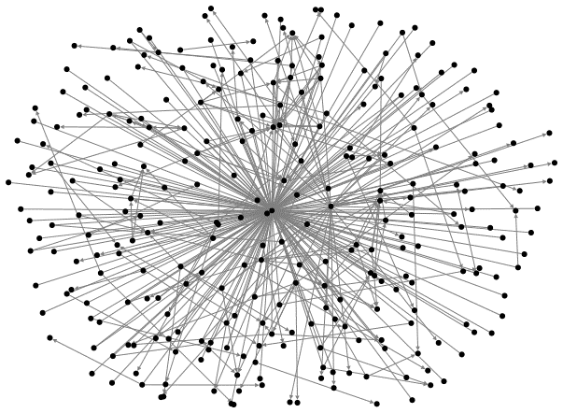

Figure 1: Graph showing all vertices and unique edges

## Metrics

|  |  |
| --- | --- |
| **Graph Metric** | **Value** |
| Graph Type | Directed |
|  |  |
| Vertices | 287 |
|  |  |
| Unique Edges | 383 |
| Edges With Duplicates | 0 |
| Total Edges | 383 |
|  |  |
| Self-Loops | 0 |
|  |  |
| Reciprocated Vertex Pair Ratio | 0.007894737 |
| Reciprocated Edge Ratio | 0.015665796 |
|  |  |
| Connected Components | 2 |
| Single-Vertex Connected Components | 0 |
| Maximum Vertices in a Connected Component | 285 |
| Maximum Edges in a Connected Component | 382 |
|  |  |
| Maximum Geodesic Distance (Diameter) | 4 |
| Average Geodesic Distance | 2.642529 |
|  |  |
| Graph Density | 0.004666066 |

## Analysis based on metrics

There are only 2 connected components. Which shows that the data we have about the tweets is very well connected. Every vertex is connected to every other vertex. There are no disconnected or single vertices in the graph. A vertex needs at most 4 hops to reach from another vertex. Since it is a directed graph degree is shown as not available.

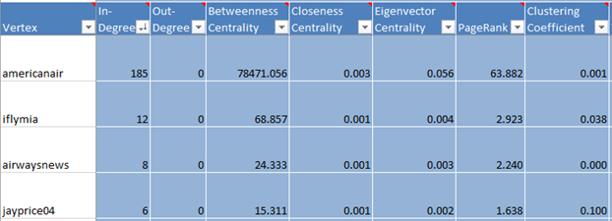

Figure 2 Vertices with highest in-degree

Maximum in-degree is 185 to amricanair vertex, but since other vertices have low in-degrees, the average in-degree of the graph has got down to 1.3.

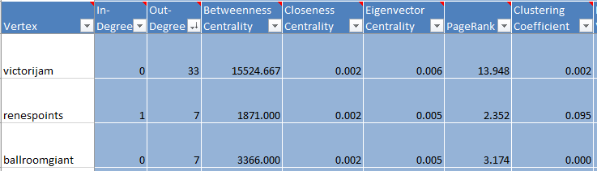

Figure 3 Vertices with highest out-degree

Maximum out-degree is 33 for ‘victorijam’ vertex. This vertex is repeatedly showing significance in different metrics.

Figure 4 Betweeness and closeness Centrality

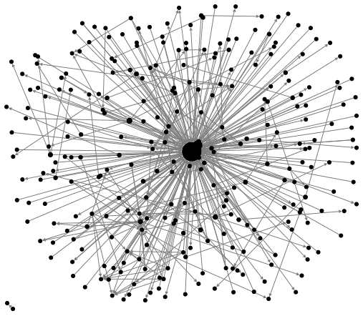

Figure 5 graph showing vertices sized by betweeness centrality

Maximum betweeness centrality is very high of about 78.5 thousand, indicates how well the vertices are connected. There are some important vertices to be identified.

Figure 6 Eigenvector Centrality and clustering coefficient

The closeness centrality maximum value is 0.05 which is very low, the graph shows that there are some major vertices to look at. The highest page rank is 63, @americanair has the highest page rank followed by victorijam.

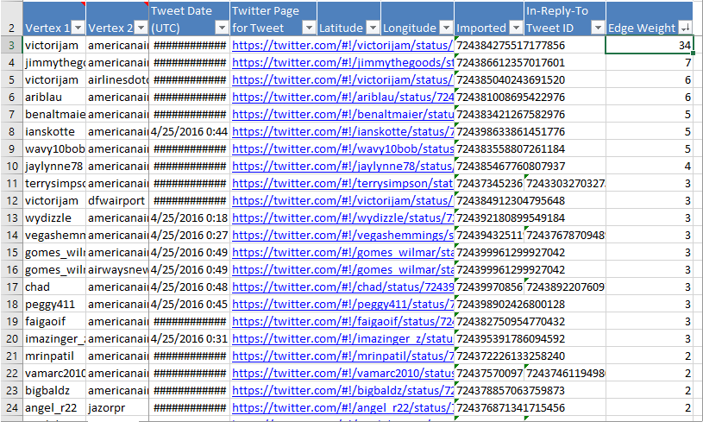

Figure 7 screen shot showing edges with their weights.

From the above table victoriJam and @americanair edge has the highest weight.

By looking at the victorijam twitter page, this account has very less number of tweets (2715) and less followers (669) too. But in the data being analyzed, victorijam tweets are the most seen ones.

When tweets of victorijam were checked at https://twitter.com/VictoriJam, @americanair was mentioned either as a positive tweet or while sharing a media file about the airplanes of different airlines. So, this vertex is like a gatekeeper that connects a bunch of nodes who mentioned @americanair in their tweets.

After auto filling the vertices size by betweeness centrality, the graph shows that @americanair vertex has the most importance and is connected to the most number of vertices. The next most influential vertex is ‘victorijam’.

## Analysis using groups

Following graph shows all the groups of vertices from the data.

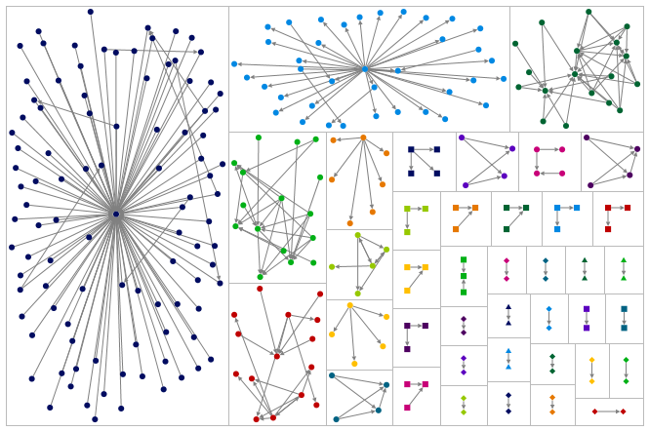

Figure 8 Groups of vertices by clustering method

There are 40 different groups. Group 1 is the largest with about 100 vertices connected to one another. @americanair is the vertex at the center with maximum connectivity. Next biggest group has victorijam with highest connectivity.

* Group 1 has a member called ‘johnacarter14’, who is founder of travelsByJC.com. He has many positive tweets on his page. He has good following too.
* Group 2 has some major vertices like Dirk Nowitzki, Demi Lovato etc making it interesting to pursue more research on their tweets about @americanair, most of them being positive ones.
* Group 4 has a vertex called ‘trebos10’, who is Tre Boston a famous football player. He has a huge following on twitter. He also has some negative tweets about AA on his page. The company has no replies for his comments.
* The vertex called ‘@theForwardCabin’ , who is a travel blogger, complained on his page about AA has a good number of followers.

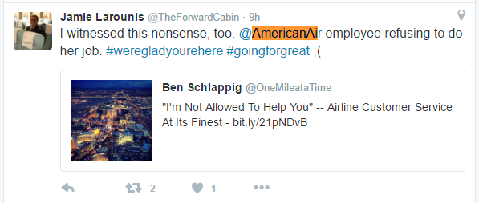

Figure 9 ‘theForwardCabin’ tweet about @americanair

One of the vertices in Group 6 ‘ballroomGaint’ is one of the highly followed members from the data we have. He is Gary Edward, has used @@americanair to give his status in most of his tweets.

## Analysis using dynamic filtering

By using dynamic filtering we tried to see which @americanair followers had the highest following on the website. We set vertex size to followers, and below is the resulting graph.

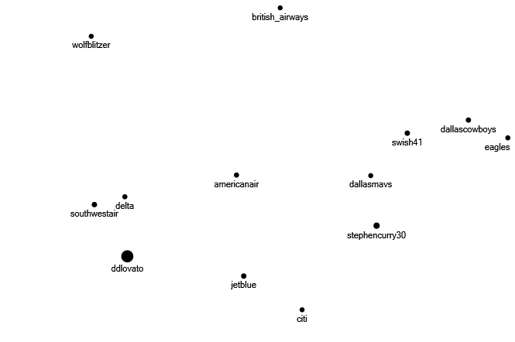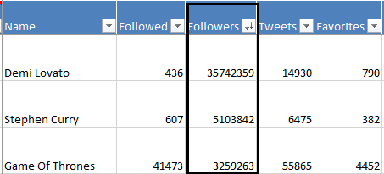

Figure 10 Graph showing vertices with most followers

The ‘most-followed’ members can reach more people and their comments or compliments about @americanairlines can make lot of difference. These highly followed members should be treated carefully to get positive tweets about the company.

# Results and findings from Twitter

* From the data we worked, it was evident that the company has some important people/ celebrities in their network.
* Though few of them tweeted compliments and mentioned company name to give their status, others had complaints that need to be accounted.
* Most complaints about the company are about flight delays, bad crew behavior, baggage delays etc.

# Business implications of Twitter network analysis

* The AA social media department has to respond to the tweets, at least to the members who have very good following.
* Make the trip special for celebrities, so that they will surely mention about the airlines on their twitter page.
* Offer deals to AA twitter followers to encourage them to retweet or share tweets and let customers from other social media network know about it.
* There appears to be exposure to gain by pursuing advertising in Airways News, as many followers of AmericanAir also follow that group.
* In addition, there are some other accounts centered on airports that show up as significant in analysis, which would be helpful to partner with where American Airlines has strong hubs.
* Also people like to take pictures of airplanes. Investments in making planes look good and/or unusual on the outside can result in free exposure when pictures of those planes are shared on Instagram and other sites.

# YouTube Analysis

YouTube started in 2005 is a video sharing website, where users can upload, watch and share videos with others.

## Cleansing

We are using 200 records. There are no duplicates in the data, so the ‘count and Merge duplicate edges’ function did not do any cleanup of the data. The data is selected basing on the views and response videos to the @americanairlines YouTube account. The data also has also got the users posting their own experience videos with @americanairlines. The data is about videos posted on the YouTube from 2006 to 2016.

Initial Graph:

The videos are posted by the airline, customers of airline, and the employees/flight attendants of the airline. There are freelance and some investigative videos are extracted. Vertex representing the YouTube videos posted with the context, reviews, comments, and views. The Edges are the relationships between the videos themselves. It is Undirected network as it is YouTube and available on public domain for everyone with account or no account.

Graph representation of the data with show graph functionality representing identified relationships for the videos. As we can see there are 11 clusters within the dataset. However, these are highly connected as identified by the fact that we have 5516 edges.

**Graph on loading the data to NodeXL:**

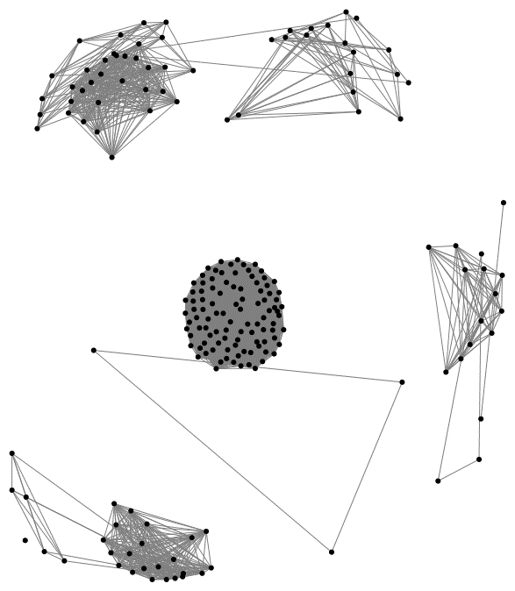

After choosing the labels for the nodes to give the names of the vertexes:

We added labels to the nodes/vertices by using the vertex name itself with the option ‘Autofill columns’.

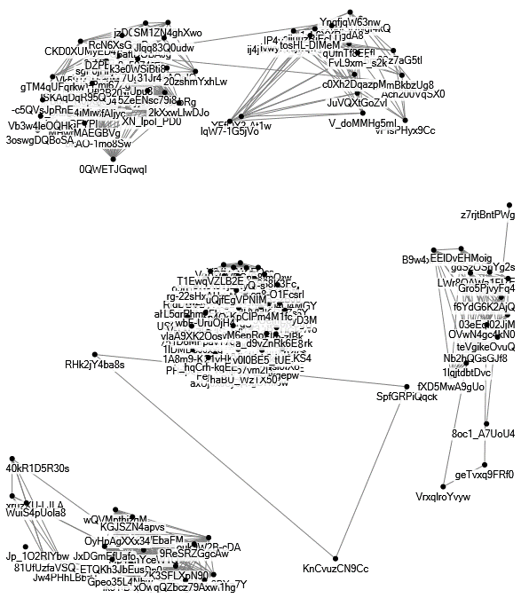

## Metrics

To know more about the data, executed the metrics using the Graph Metrics tab. The overall captured network is represented here with the information on vertices, edges and the information on the connectedness and the distance between them. It computed metrics for various metrics such as Vertex degree, Vertex betweenness and closeness centralities, Vertex eigenvector centrality, Vertex PageRank, and clustering coefficient. Since this is an undirected network, the values for in-degree and out-degree metrics returned were 0.

|  |  |
| --- | --- |
| **Graph Metric** | **Value** |
| Graph Type | Undirected |
|  |  |
| Vertices | 200 |
|  |  |
| Unique Edges | 5516 |
| Edges With Duplicates | 0 |
| Total Edges | 5516 |
|  |  |
| Self-Loops | 0 |
|  |  |
| Reciprocated Vertex Pair Ratio | Not Applicable |
| Reciprocated Edge Ratio | Not Applicable |
|  |  |
| Connected Components | 13 |
| Single-Vertex Connected Components | 1 |
| Maximum Vertices in a Connected Component | 99 |
| Maximum Edges in a Connected Component | 4851 |
|  |  |
| Maximum Geodesic Distance (Diameter) | 1 |
| Average Geodesic Distance | 0.982281 |
|  |  |
| Graph Density | 0.27718593 |
| Modularity | Not Applicable |
|  |  |
| NodeXL Version | 1.0.1.350 |

There are 200 vertices and 5516 unique edges. The high number of edges tells us that the interaction among the vertices is higher. It is an undirected network with 13 connected components. In addition, there is and 1 single vertex connected component. Out of the connected components, there is one that has the majority of the vertices/edges, which is 99 vertices and 4851 edges. There are no self-loops.

The Geodesic distance maximum is 1 which is very less. The average Geodesic distance is 0.98 which is close to the maximum geodesic distance. It appears like the distance between two vertices is pretty much equal.

## Analysis based on metrics

|  |  |
| --- | --- |
| **Degree:** |  |
| |  |  |  | | --- | --- | --- | | |  | | --- | |  | |  | |  |  | |  |  | |  |  | |  |  | |  |  | |  |  | |  |  | | Minimum Degree | 0 | | Maximum Degree | 98 | | Average Degree | 55.160 | | Median Degree | 22.000 | |  |

Maximum degree has 98 value, which means the number of connections/edges an individual vertex has that has this maximum value. Average degree is at 55 which is also pretty high as an average vertex having 55 edges. That explains why 200 you tube videos have 5516 edges. The 22 number of degrees is exactly the middle number of degrees with the same number of edges.

**Betweenness Centrality:**

|  |  |  |
| --- | --- | --- |
| |  | | --- | |  | |  |
|  |  |
|  |  |
|  |  |
|  |  |
|  |  |
|  |  |
| Minimum Betweenness Centrality | 0.000 |
| Maximum Betweenness Centrality | 0.000 |
| Average Betweenness Centrality | 0.000 |
| Median Betweenness Centrality | 0.000 |
| Median Betweenness Centrality | 0.000 |

The betweenness centrality is zero, which means, there is no specific video that has a positive centrality. No specific node is acting like a bridge to other nodes. It appears all the videos are at the same level. It does not look like any specific video is central to any relationship. No individual video has any high influence compared to the other videos in the network.

**Closeness Centrality:**

|  |  |  |  |  |  |  |  |  |  |  |  |  |  |  |  |  |  |  |  |  |  |  |  |  |
| --- | --- | --- | --- | --- | --- | --- | --- | --- | --- | --- | --- | --- | --- | --- | --- | --- | --- | --- | --- | --- | --- | --- | --- | --- |
| |  |  |  | | --- | --- | --- | | |  | | --- | |  | |  | |  |  | |  |  | |  |  | |  |  | |  |  | |  |  | | Minimum Closeness Centrality | 0.000 | | Maximum Closeness Centrality | 1.000 | | Average Closeness Centrality | 0.076 | | Median Closeness Centrality | 0.028 | |  |

All the above numbers represent the nodes being very close to each other. There is not much distance between the nodes, so the nodes are not far off from each other. However, the numbers are not really meaningful in an undirected network.

**Eigenvector Centrality:**

|  |  |  |
| --- | --- | --- |
| |  | | --- | |  | |  |
|  |  |
|  |  |
|  |  |
|  |  |
|  |  |
|  |  |
|  |  |
| Minimum Eigenvector Centrality | 0.000 |
| Maximum Eigenvector Centrality | 0.010 |
| Average Eigenvector Centrality | 0.005 |
| Median Eigenvector Centrality | 0.000 |

It represents the influence of a node/vertex in the network. The values are low marks that the influence is low for most nodes. There is literally not much to read from this numbers.

**PageRank:**

|  |  |  |  |  |  |  |  |  |  |  |  |  |  |  |  |  |  |  |  |  |  |  |  |  |  |  |
| --- | --- | --- | --- | --- | --- | --- | --- | --- | --- | --- | --- | --- | --- | --- | --- | --- | --- | --- | --- | --- | --- | --- | --- | --- | --- | --- |
| |  |  |  | | --- | --- | --- | | |  | | --- | |  | |  | |  |  | |  |  | |  |  | |  |  | |  |  | |  |  | |  |  | | Minimum PageRank | 0.000 | | Maximum PageRank | 1.000 | | Average PageRank | 0.995 | | Median PageRank | 1.000 | |  |
|  |  |

This is another way of representing the influence of individual nodes over others. This is an alternative to eigenvector centrality. Average page rank is 1 which tells that most of the nodes are equal in their influence.

**Clustering Coefficient**:

|  |  |  |
| --- | --- | --- |
| |  | | --- | |  | |  |
|  |  |
|  |  |
|  |  |
|  |  |
|  |  |
|  |  |
|  |  |
| Minimum Clustering Coefficient | 0.000 |
| Maximum Clustering Coefficient | 1.000 |
| Average Clustering Coefficient | 0.985 |
| Median Clustering Coefficient | 1.000 |

Clustering Coefficient shows us how the nodes tend to cluster together. Clustering coefficient is always between 0 and 1 since it is the ratio of number of edges to a member and the maximum number of edges that could possibly exist. Low values represent they are in close clusters.

Metrics associated to individual vertices and in comparison with other vertices:

* Closeness centrality is low for those vertices that have high degree of connections.
* Eigenvector centrality has some meaningful value for those vertices with high degree of connections.
* PageRank is one for all the vertices except for one vertex. The last Vertex that has a ‘0’ PageRank does not have any edges.
* Clustering coefficient is ‘0’ for those vertices that either does not have an edge or has only one edge. For all other vertices that have more than 1 edge, the clustering coefficient is 1.

After the Metrics are calculated and graphed, here are some important visualizations:

**How many times the videos were viewed:**

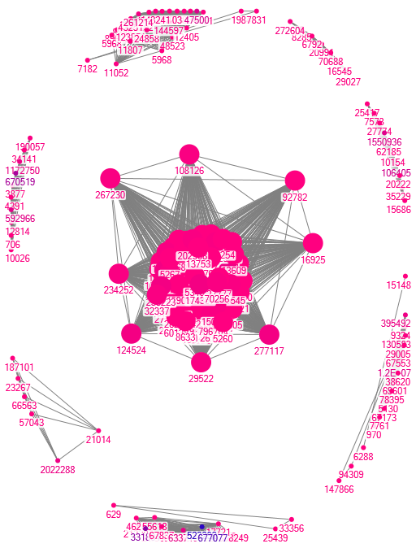

**How many times, the videos is liked:**

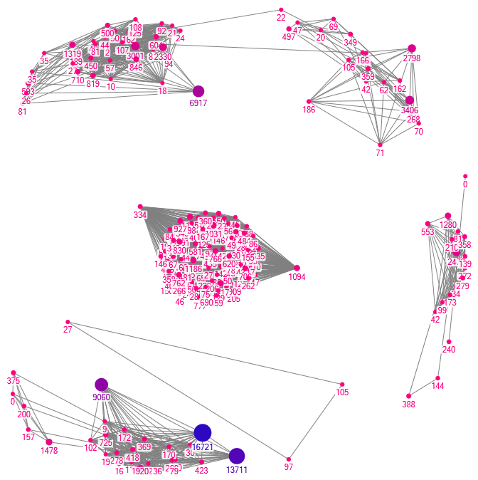

**Author (Vertex Label) of the content and views (vertex size):**

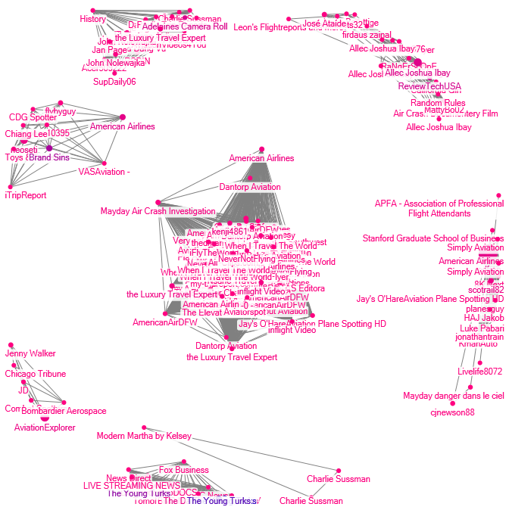

**Title (Vertex Label) of the video and views (vertex size):**

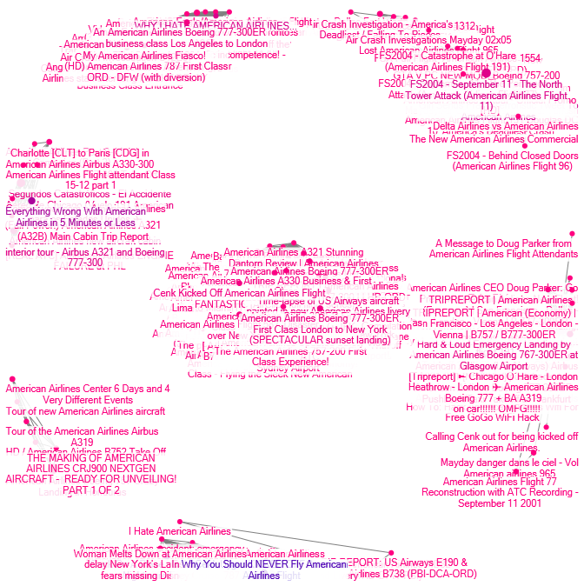

## Analysis using groups

Categorized the videos into 2 groups. The first group is the videos posted by the customers like review videos and trip videos, the vertices of which are identified by the Triangle symbol. The second group is having the videos posted by the American Airlines and its employees, the vertices of which were identified by the square symbol. The color of the symbol is defaulted for the customer review videos. The color for the American Airlines and their associate videos are represented with green color.

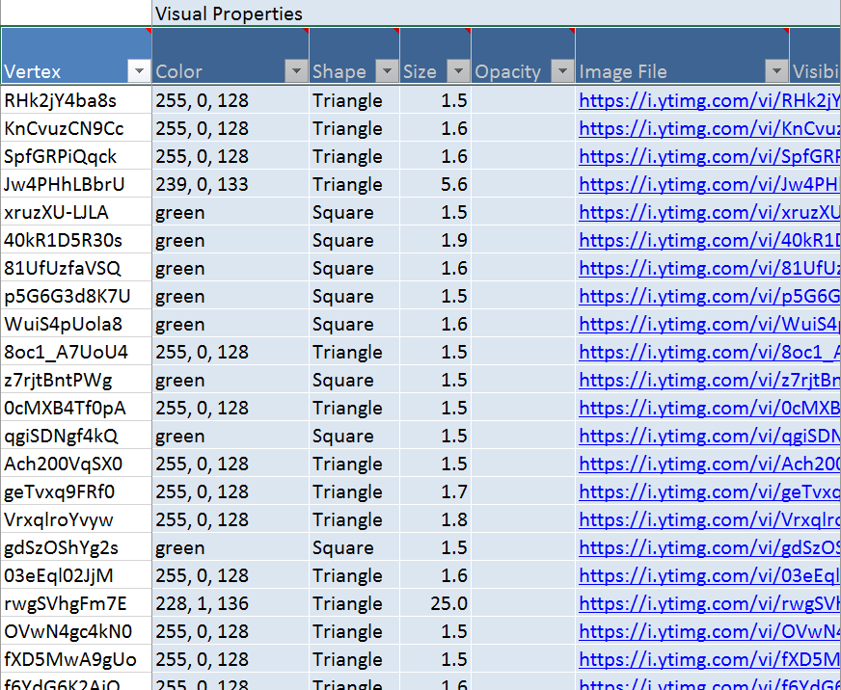

Here is the graph to start with the groups.

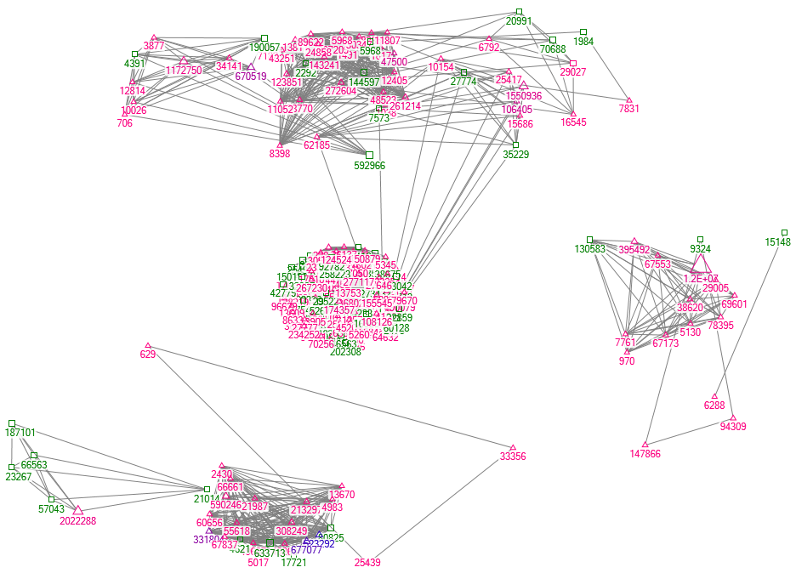

As we can observe, the representation of the videos in green are the ones posted by American Airlines with the number of views of those videos. It appears the customer reviews videos are most watched compared to the videos posted by the Airline.

**Cluster Analysis - Groups by Cluster:**

**Groups:**

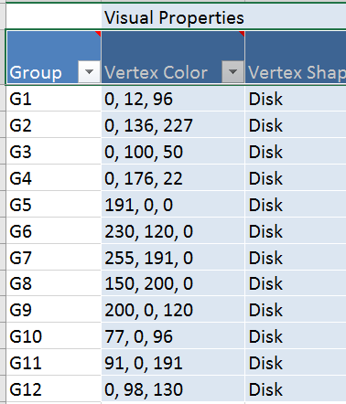

Using Layout options to show the 12 groups in the graph:

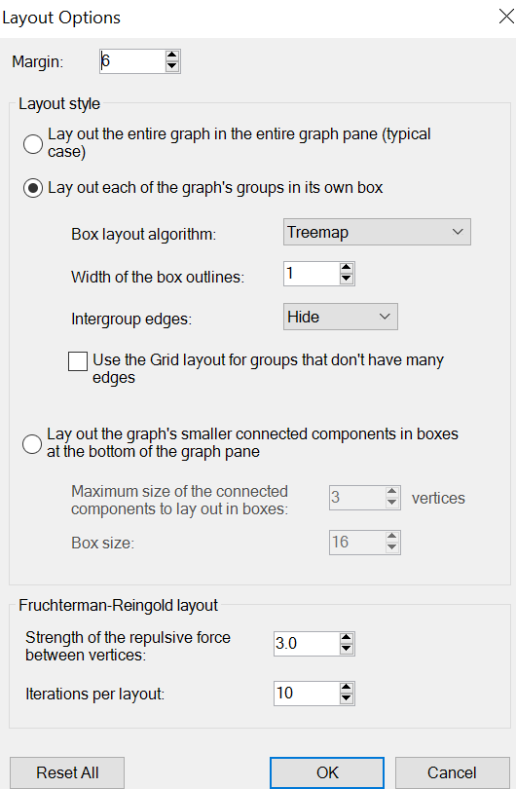

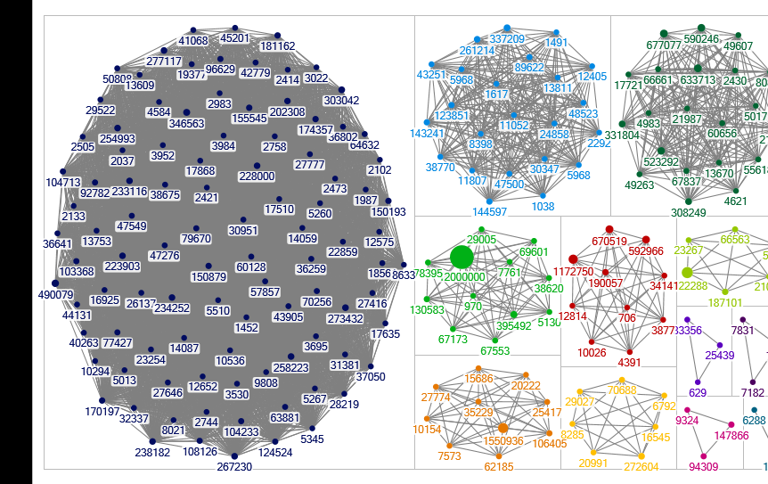  
Here we can see all the 12 groups in one box each by size. The connections of the groups in between them are hidden.

**Groups with Autofill columns:**

Vertex size for # of likes and the vertex label with # of views:

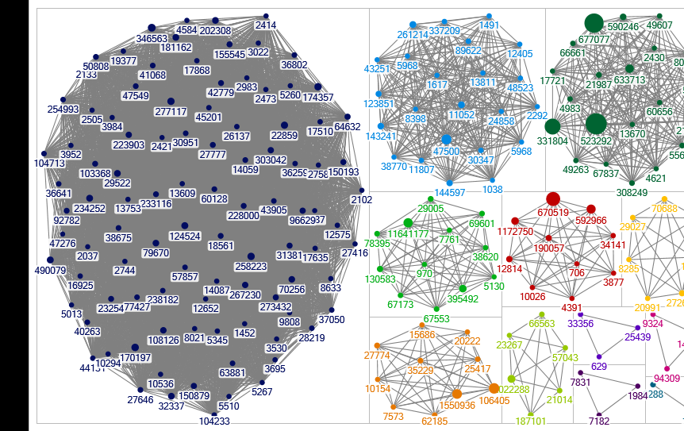

Groups displayed with group options for showing the color of the vertices as defined in the groups worksheet and the shapes identified in the Vertices worksheet:

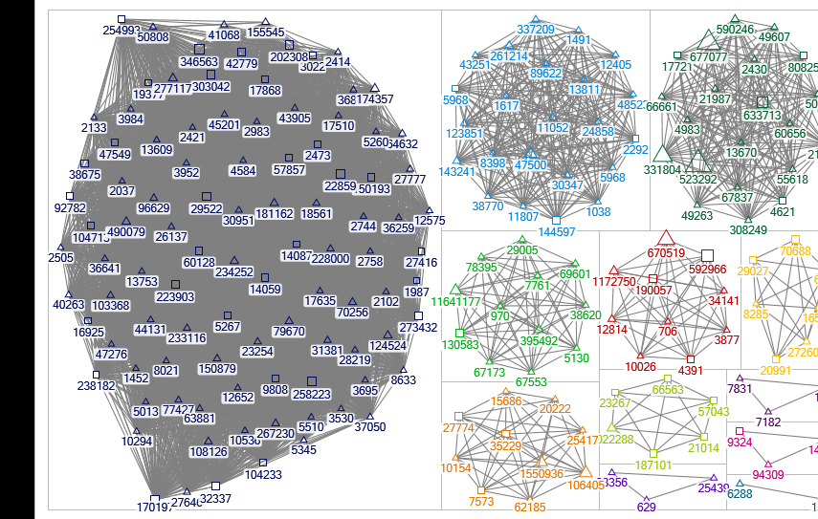

**Reducing the crowdedness of the graph by using the Layout options:**

The videos that are connected less (3 or less vertices) are pushed down:

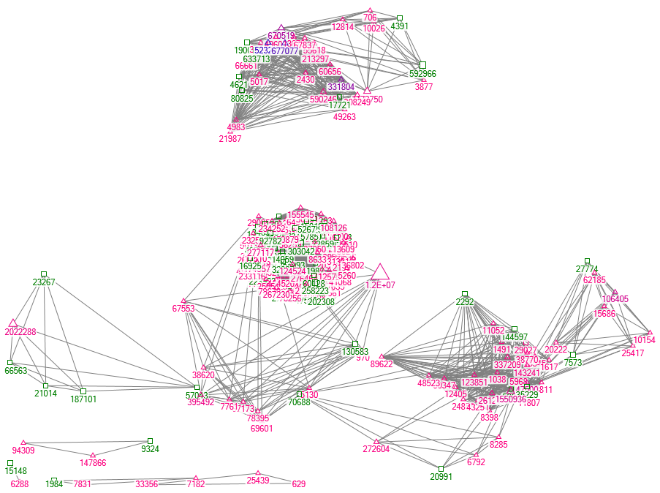

## Analysis using dynamic filtering

By the size of the vertex (from 2.50 to maximum which is 25.00):

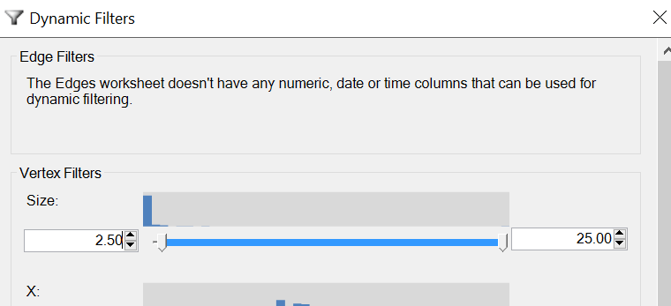

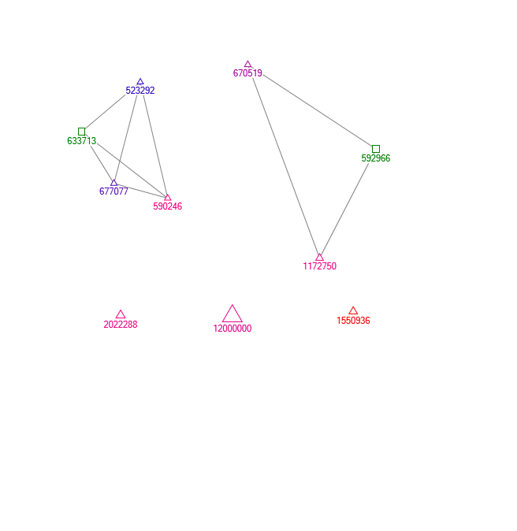

We are showing only the videos that have more than 2.50. The number of views of the video has the vertex size represented. The color of the vertex changes from purple to blue depending on the number of likes of the video. The videos represented in blue color are most liked.

**Dynamic filtering - Videos watched for more than 100,000 times:**

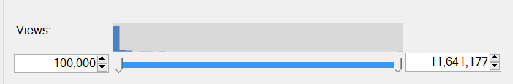

**Result:**

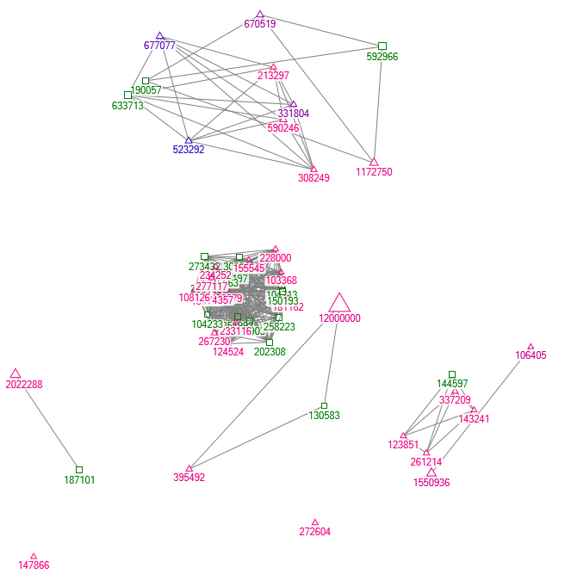

**SubGraphs:**

Subgraphs for the individual vertex with degree 2.0 and greater were chosen. This is to show the egocentric vertexes showing the connectedness of the video to other videos and to the next level videos, 2 levels of connectedness. Here is the result for those vertexes:

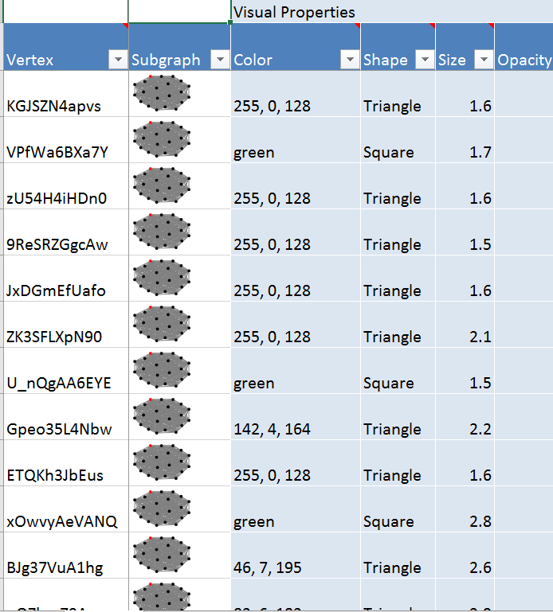

## Group Analysis based on Closeness Centrality:

Based on closeness centrality 5 groups were formed and the result graph is shown below.

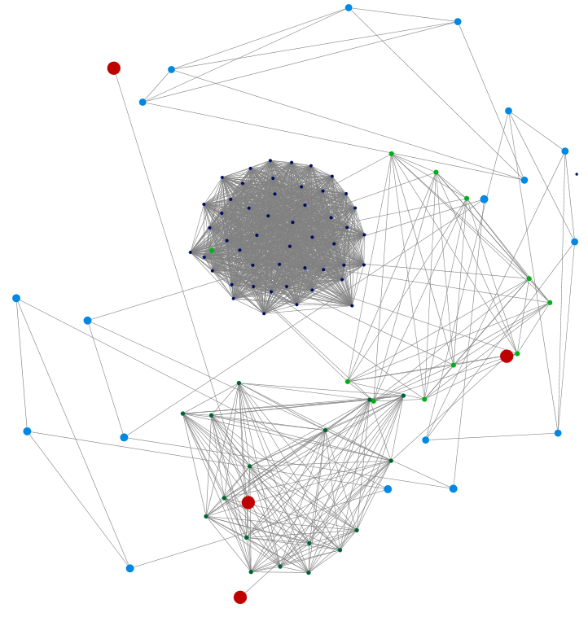

There is one standalone group on the upper right. This sixth group is formed for the remaining vertices which were not grouped based on closeness centrality values. Below shown graph have five vertices with sixth one being removed.

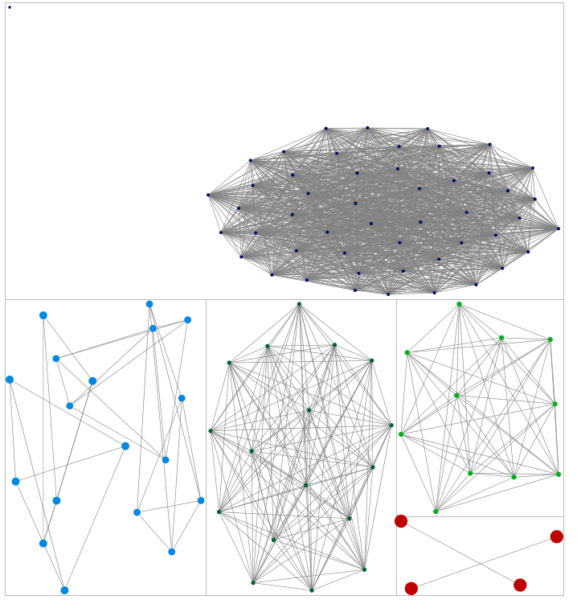

Investigating some example of each group to see if there is a pattern, below is the graph with the pattern word superimposed:



NORMAL OR POSITIVE

CRASH

KICKED OFF / TURBULENCE

REROUTE

MAYDAY

Some of these groups are similar, such as mayday and crash, but the language was extreme in the mayday ones which may explain the grouping separately.

Now considering all of these groupings, we can analyze the videos which was most viewed.

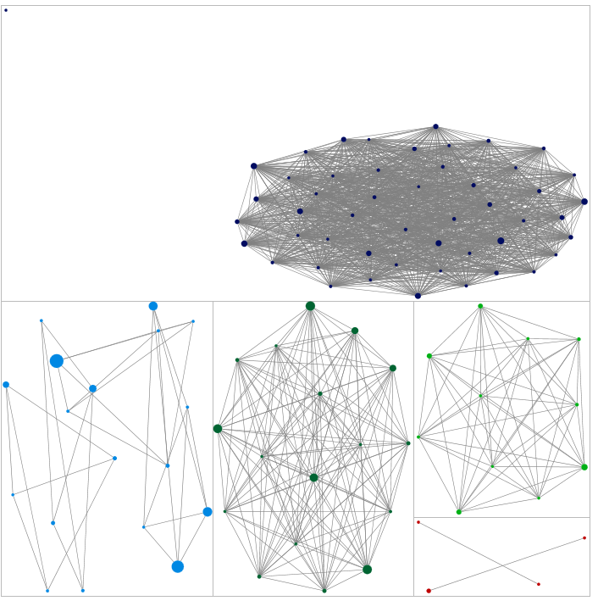

CRASH

KICKED OFF / TURBULENCE

REROUTE

NORMAL OR POSITIVE

MAYDAY

Clearly bad news sells, because the middle and left bottom group have the most views.

Looking more specifically at the most views, the top one (1,499,294 views) is a 9/11 conspiracy video, which isn’t really directly related to American Airlines. The next ones discuss issues with American Airlines. On a bright note, the 5th most watched is a positive review of the Boeing 787 Dreamliner which was added to the American fleet, and the 6th is a more general video about upgrades of planes. Both appear to be either published by American Airlines, or a paid publication.

# Results and findings from YouTube

* The influence of the videos (vertices) can be understood by the number of views, number of likes and the comments posted underneath the video.
* There is not much centrality to the videos posted on the YouTube as the videos are not directed to a pre-determined group. They are directed at general public.
* There are individual/business clientele that are posting their reviews and trip reports of a trip/flight experience.
* There are many promotional videos by the American Airlines.
* There are instances of customers getting kicked out of the airlines and we don’t see response to those incidents by the Airline.

# Business implications of YouTube network analysis

* There are videos that need to be responded to by the Airline to counter the negative publicity that is brought by some of the bad customer experience videos.
* Airline need to put in more promotional videos showing the best of service and amenities provided.
* Airline needs to enlist help from some professional services companies to promote positive publicity by few users.

# Facebook Analysis

## Cleansing

Data was downloaded from the American Airlines fan page using NodeXL Pro. Due to errors in NodeXL, ended up using 3 days’ worth of data from April 24 through April 26, as attempts to download larger datasets resulted in errors.

Duplicate edges were removed and collapsed to clean up the data, which was then analyzed. The two graphs below show the network as a whole, and then with American Airlines highlighted, which illustrate the centric nature of this network.

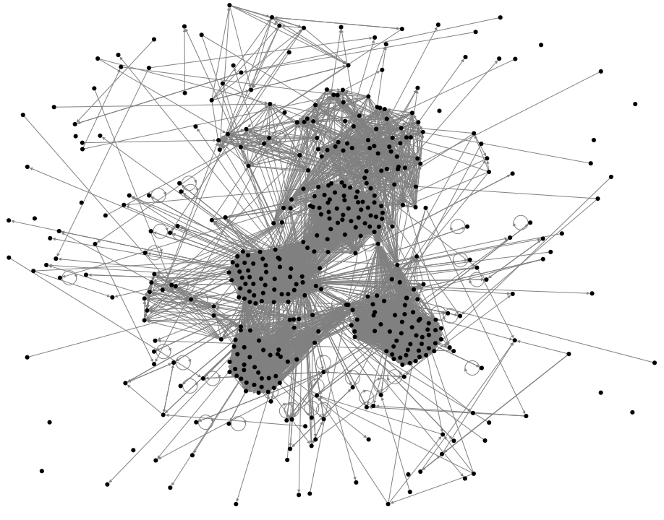

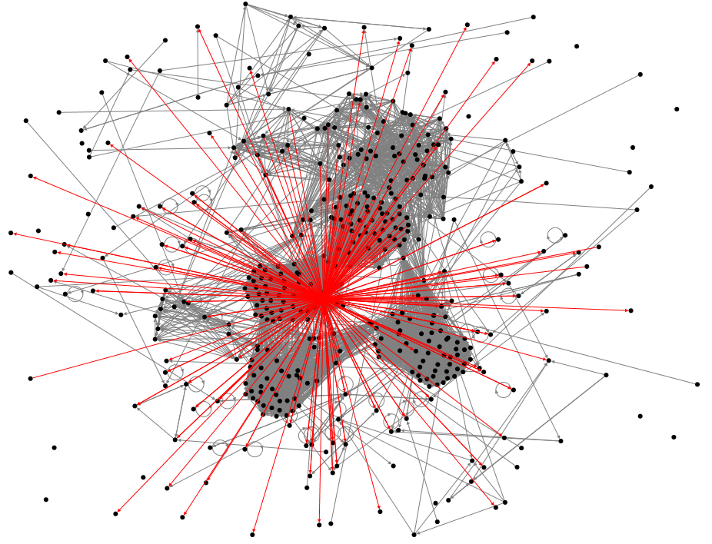

## Metrics

|  |  |
| --- | --- |
| **Graph Metric** | **Value** |
| Graph Type | Directed |
|  |  |
| Vertices | 455 |
|  |  |
| Unique Edges | 6034 |
| Edges With Duplicates | 0 |
| Total Edges | 6034 |
|  |  |
| Self-Loops | 50 |
|  |  |
| Reciprocated Vertex Pair Ratio | 0.027296137 |
| Reciprocated Edge Ratio | 0.053141711 |
|  |  |
| Connected Components | 21 |
| Single-Vertex Connected Components | 13 |
| Maximum Vertices in a Connected Component | 378 |
| Maximum Edges in a Connected Component | 5596 |
|  |  |
| Maximum Geodesic Distance (Diameter) | 6 |
| Average Geodesic Distance | 2.744893 |
|  |  |
| Graph Density | 0.028968388 |

## Analysis based on metrics

This snapshot in time, while only 3 days in length, does present some interesting information.

This directed graph has 455 vertices, with 6034 unique edges (none with duplicates as they were removed). This results in a graph density of 0.0289, which is not overly dense but does have some density.

There are also 50 self loops in this data, approximately 10% of the vertices. That means vertices with edges that refer back to themselves. This is not unusual in Facebook, as sometimes people will like their own posts or comment on them in order to drive more traffic to them.

0.0273 is the reciprocated vertex pair ratio, meaning where vertices have a relationship both ways along an edge. In addition, 0.0531 is the reciprocated edge ratio, meaning where an edge goes both ways.

This data consists of 21 separate components, of which 13 are single vertex. The largest component has 378 users in it, and the largest from the perspective of number of edges (which might or might not be the same component) is 5596 edges.

The maximum geodesic distance is 6, so there is some separation among the user group. Even the average is 2.7.

## Analysis using groups

First we will group using a cluster algorithm, first trying the default Clauset-Newman-Moore, with the option of grouping all neighborless vertices into one cluster. This results in 15 groups:

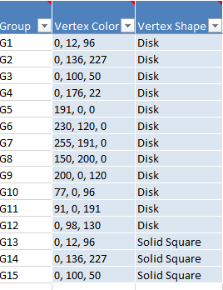

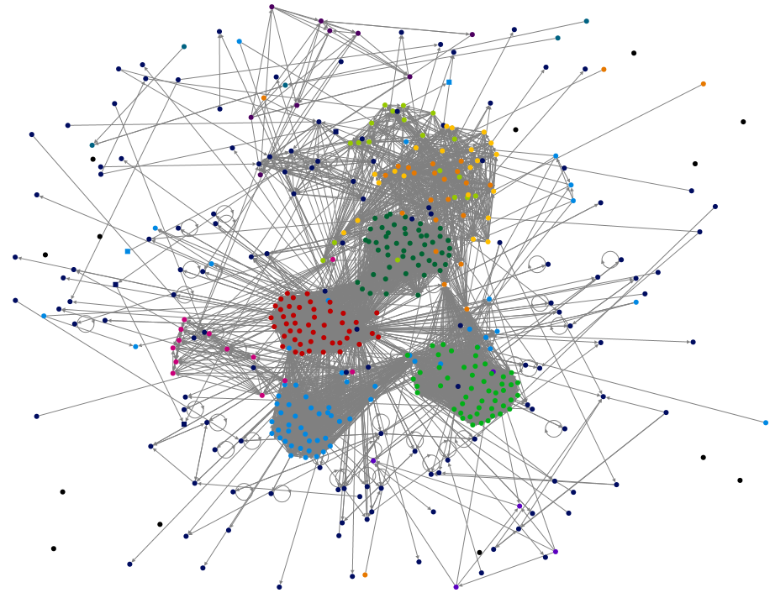

Overall the grouping algorithm did seem to group together the obvious clusters, with the exception of the upper right cluster, which has a couple groups in it.

Group 1 contains American Airlines, and appears to be the largest group looking at the graph:

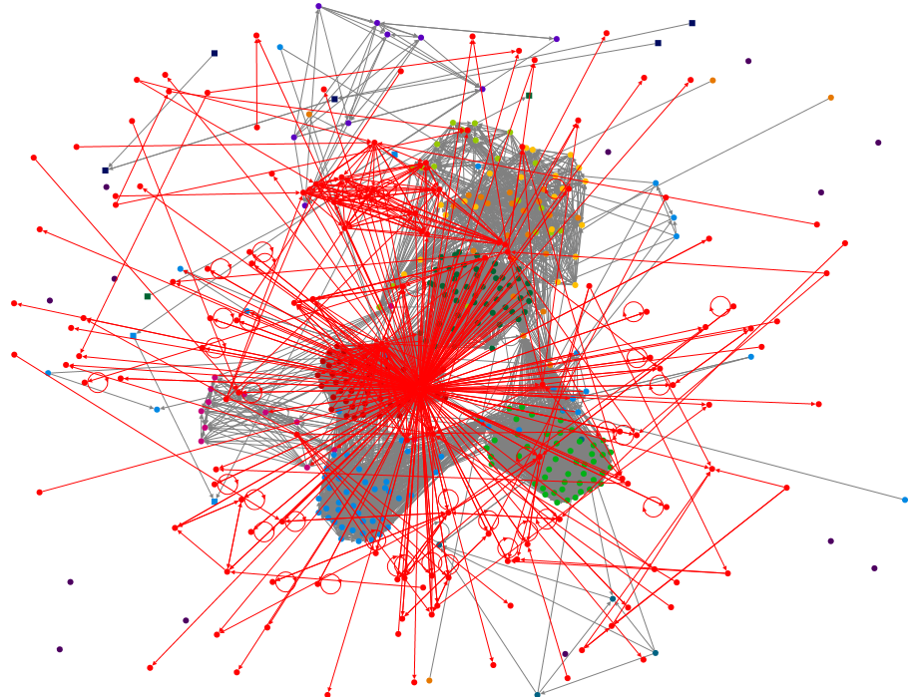

Whereas some of the other groups are fairly small, such as G15 which has only 1 edge. Note that all of the edgeless vertices are grouped in G10.

A graph of this grouping results in the following graph:

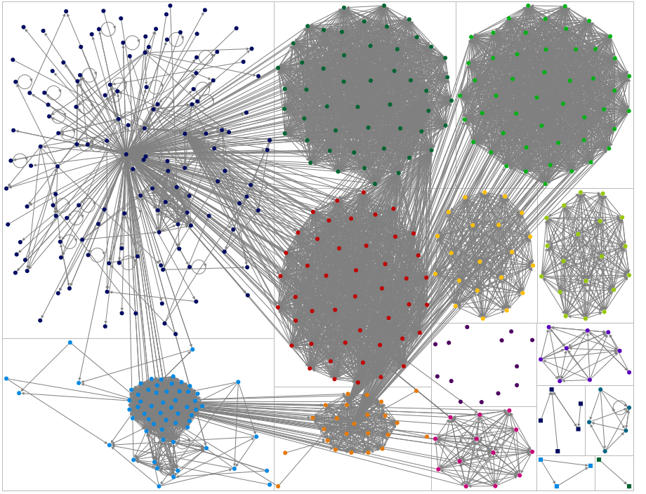

MILITARY DOG NOT ALLOWED

AIRPLANE PHOTO

SALE OFFER

AIRPLANE PHOTO

MIAMI MUSIC SHOW

WORST

SEAT CANCEL

PICTURES

THANK YOU

ONE POST: THANK YOU FROM MARINE

Note that the text boxes are highlighting what kind of comments are in each group.

What is interesting here is all of the interconnectedness among the groups.

In addition, single posts can generate quite a bit of activity, such as the marine thank you in the bottom left, or the various pictures posted.

Many of the comments about the experience being bad link to people traveling to the music show, or the marine thank you.

Pictures seem to be something people like or comment on a lot, and generate a lot of traffic in general.

**BUSINESS RECOMMENDATION:**

1. Make sure to frequently post pictures of airplanes and destinations, and if AA is supporting a large event in particular. Even if people complain about AA in general, they might also like the photo, for example.
2. Reply to as many negative posts as possible in as positive a manner as possible, because one post can generate quite a bit of traffic, be it negative or positive.

Next, since there are different types of edges, make each type a different color to try to decipher what is going on a bit more:

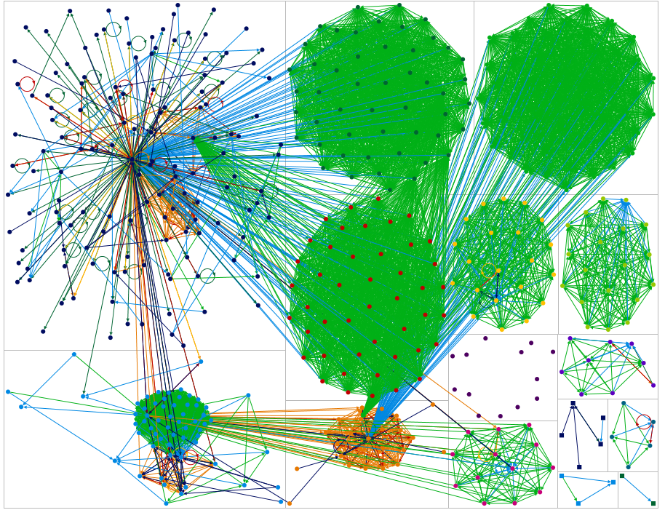

To clean up the view, elect to remove all of the co-like edges, where two vertices (FB users) both liked the same thing.

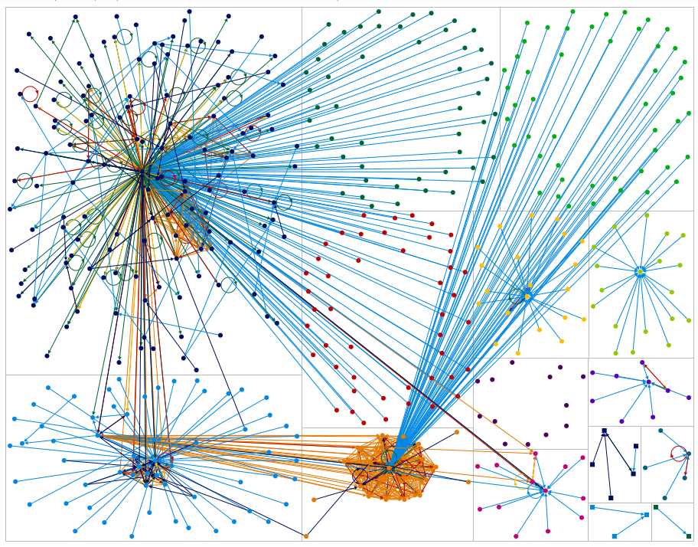

## Analysis using dynamic filtering

First item is to see how closely related the vertices are, by filtering out edges with lower relationships, by moving RelationshipNum up to 2. Result gets rid of some of the cross talk among one group in the lower middle, and other orange. No filtering on the left, after latter filter on right.

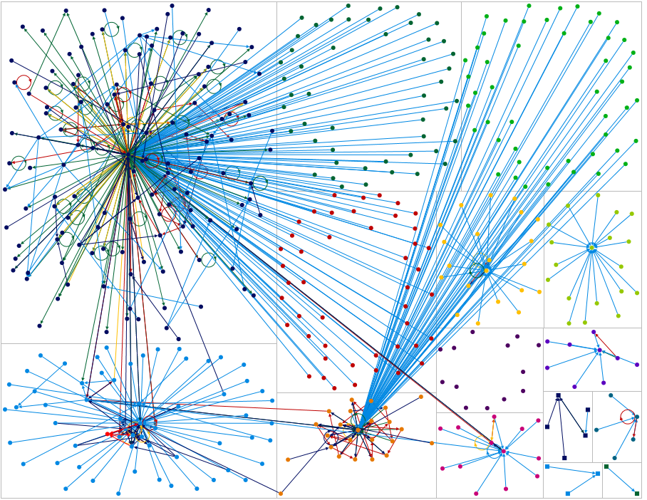

Very little else changes until RelationshipNum is increased to 5, at which point the graph look like left below. Maxing out at 7 gives the following graph on the right, showing only the vertices with the most number of relationships:

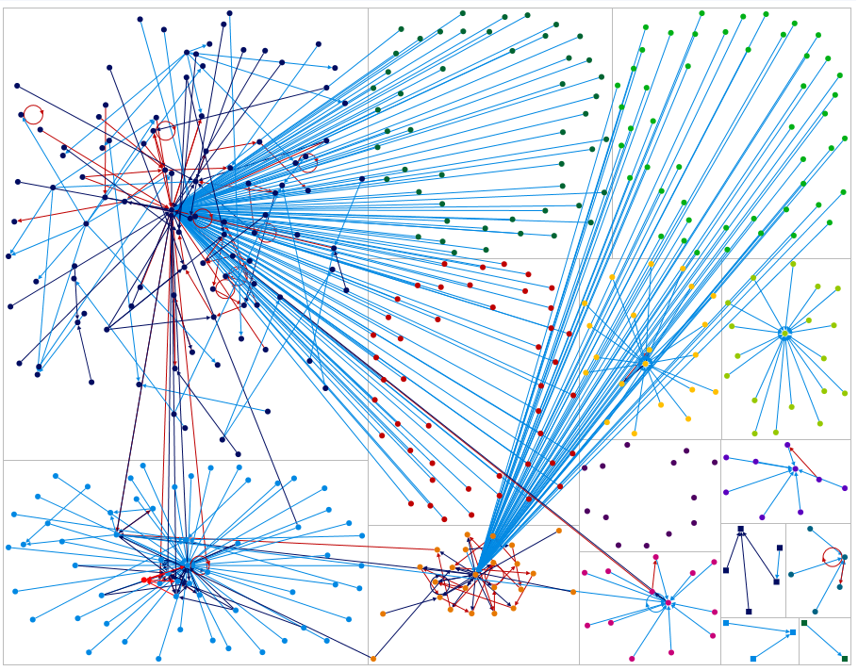 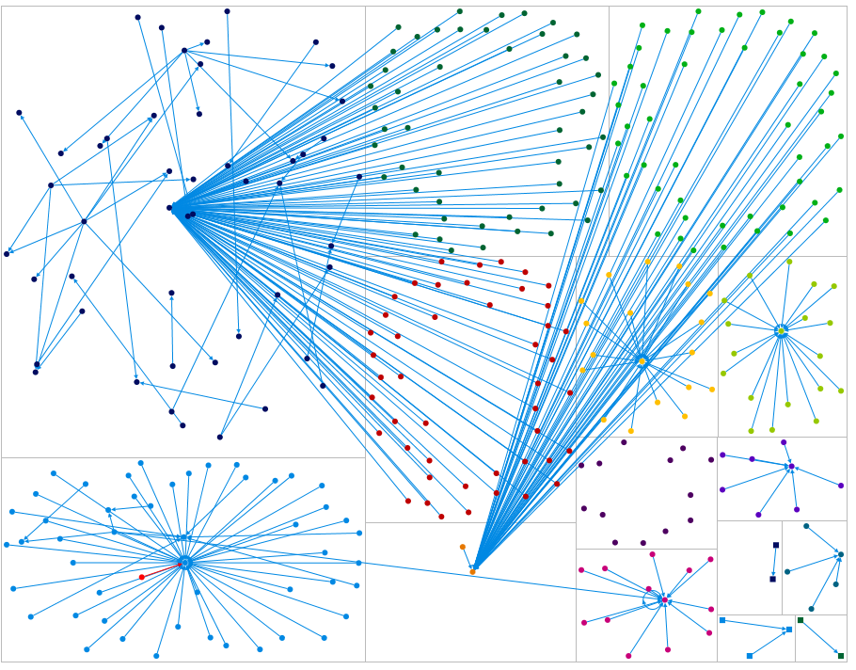

These are essentially the most influential posts. For example the one in the upper left that has two groups in the middle branching off of it are posts made by American Airlines.

Next, look for connections with an edge weight greater than 0 (which was generated earlier by collapsing all duplicate edges and creating an edge weight column in the Edges tab.)

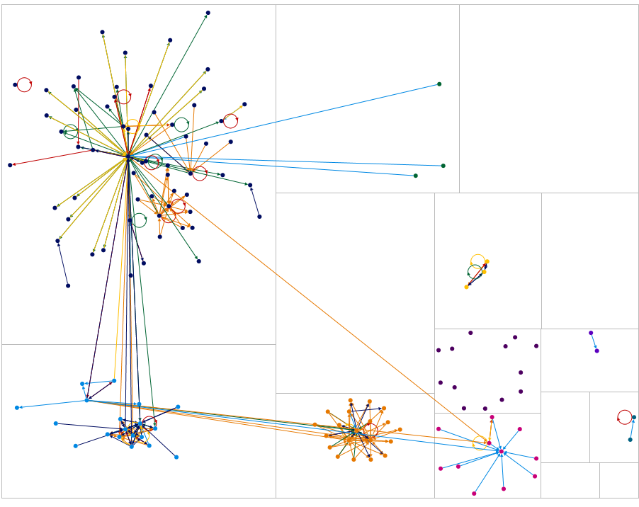

This drastically reduces the vertices and edges on the graph, meaning most of the connections were one-way, typical in a fan page set up as people are liking something, and the fan page itself is not likely doing much in return unless a comment or post is very important to a business, due to the sheer volume of activity on social networks.

Bumping edge weight up to 3 trims it even more:

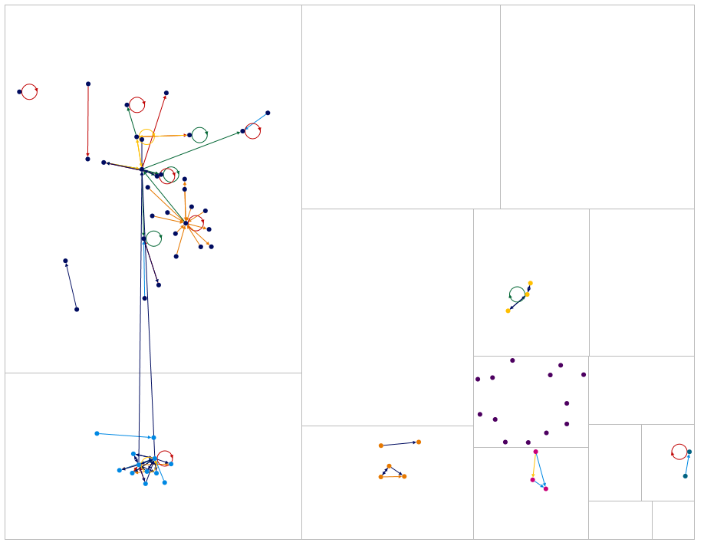

These nodes have a fair amount of connection to still be in place. In fact, there is little change when the Edge Weight is bumped up further, until you get to 5:

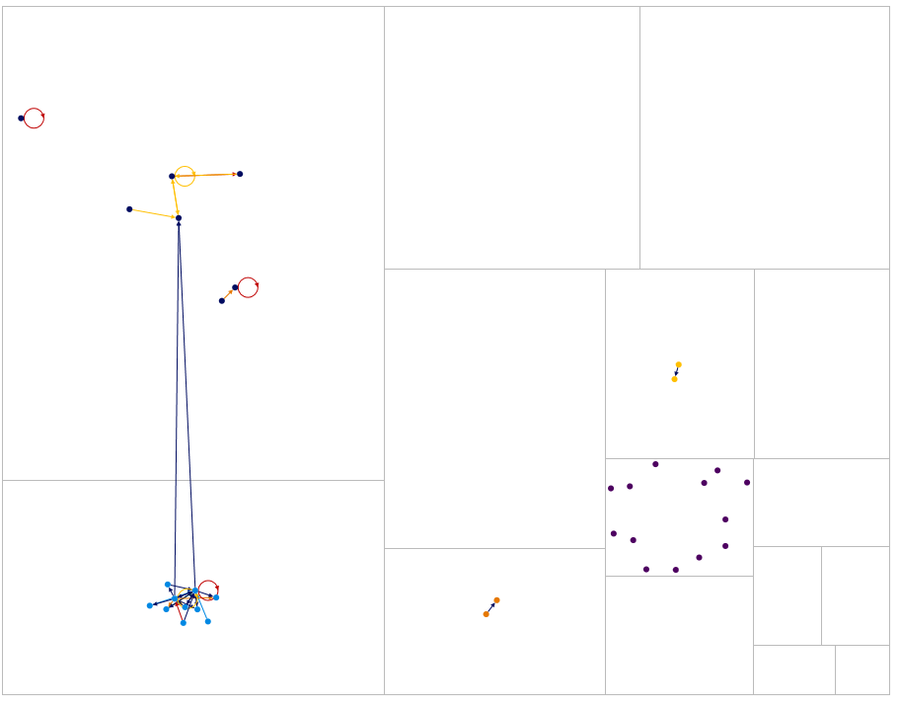

Moving on, we next look at in-degree, to see which nodes have one edge or more coming in to them. What this does is get rid of vertices that only have out edges, in other words people who just are commenting or liking, but not participating in the social media conversation themselves.

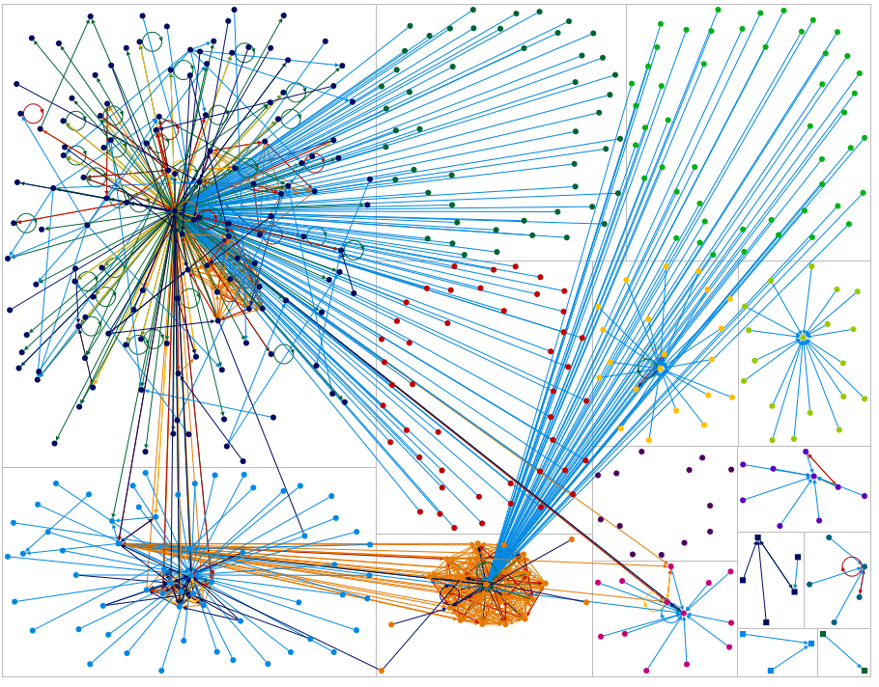 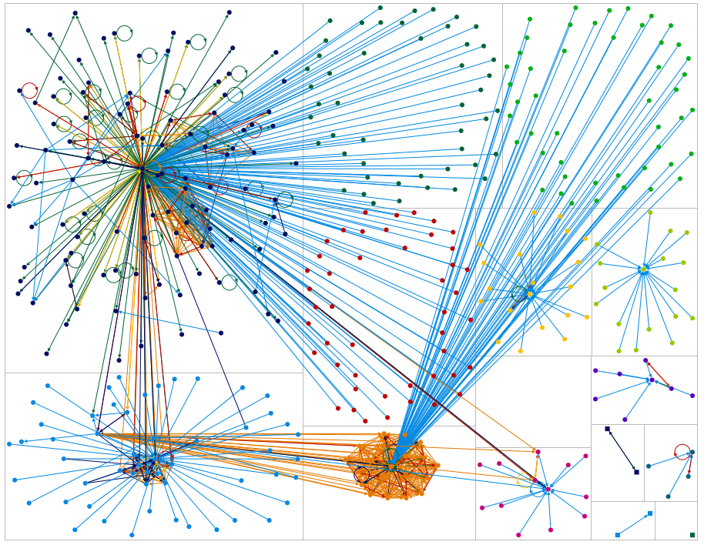

Although the difference may no be immediately obvious, there are clearly fewer vertices in the top left, which probably represent people who are just watching the AA fan page.

Moving the filter up to 5, quite a few vertices disappear. The second picture shows with in degree increased to 20

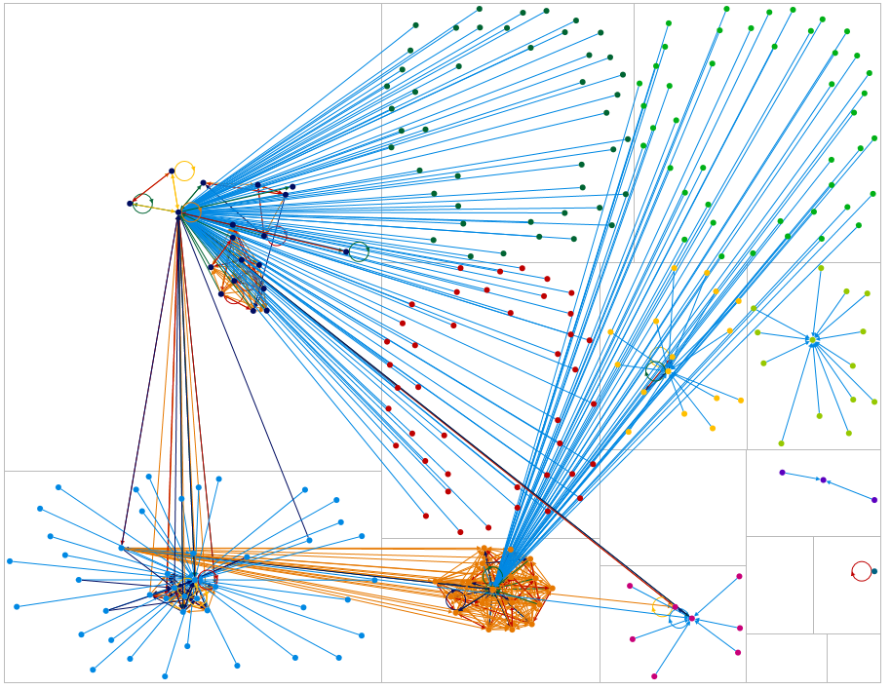 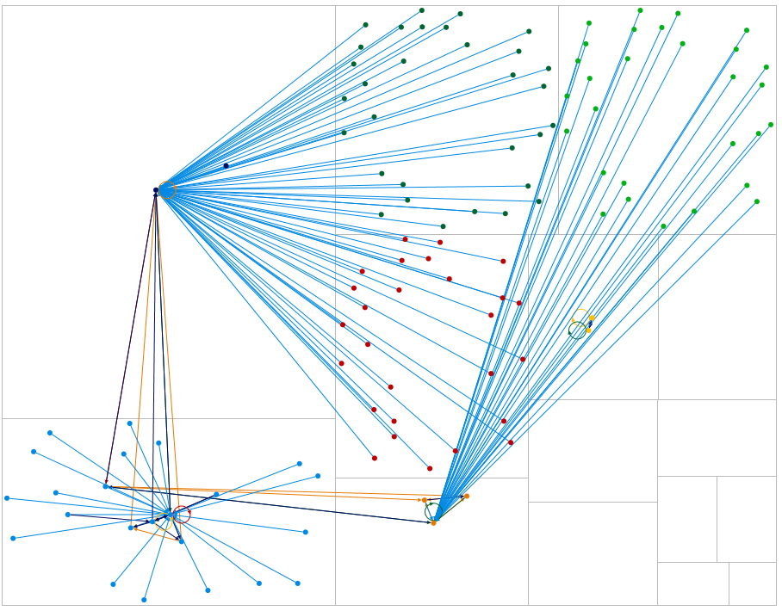

At the point of 20, only the most influential vertices are included.

Out Degree shows only vertices who have a certain number of connections going out from themselves. Increasing this just to two decreases the number of edges quite a bit, and vertices as well, especially in the lower right. Below is with Out Degree set to 0 and then 2

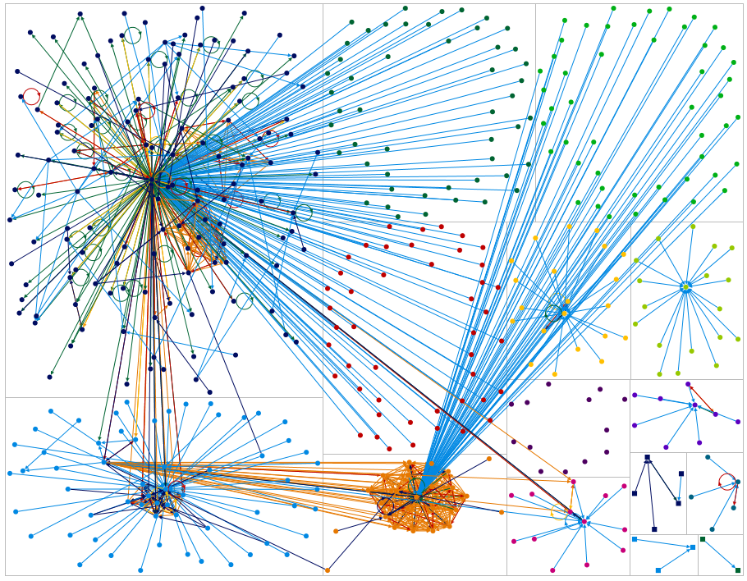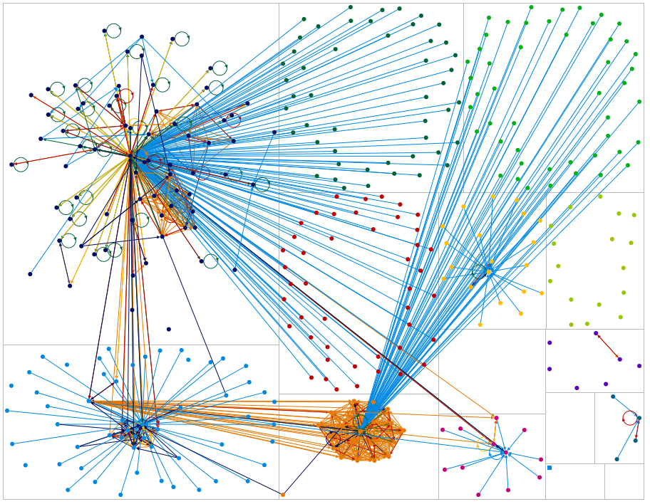

Increasing out degree to 10 significantly reduces the number of edge. Only the most “talkative” vertices remain.

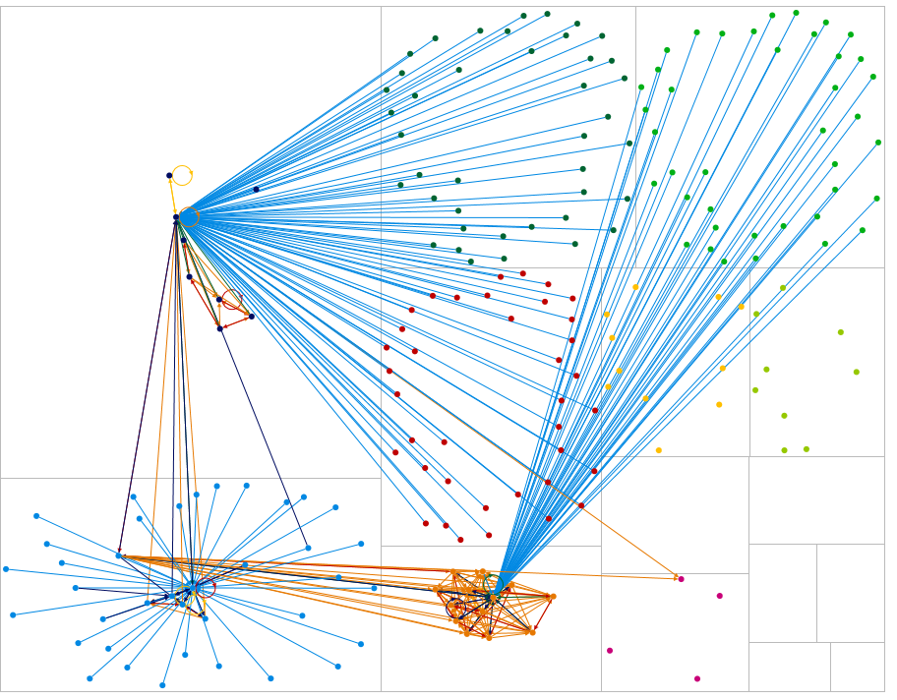

Betweenenss centrality changes drastically when going from a filter of 0, meaning show all, to 1, where the vertex is the shortest path

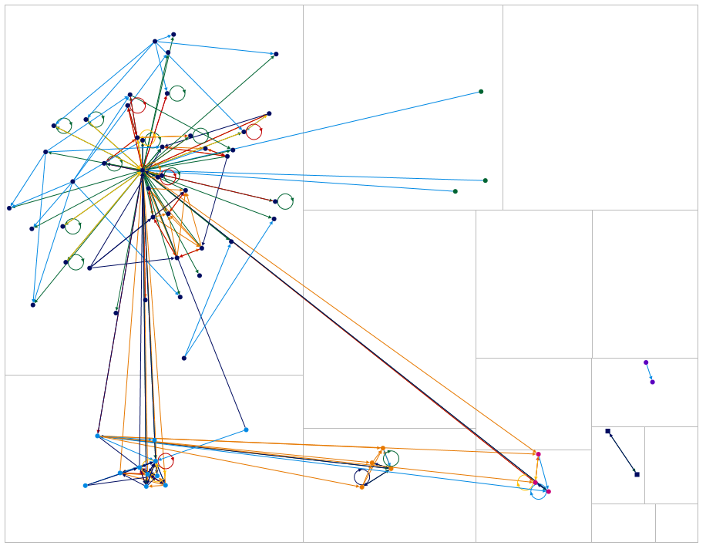

This means many of the vertices had nothing between them, they were only one path from vertex to vertex with no connection to another vertex. This happened in the upper right for example, where almost all of those directed edges pointed back to the bottom middle, but none of the likes came back or went anywhere else. Everyone was just liking a picture, and the picture what not liking anything else or commenting on anything else, the relationship is just vertex to vertex, or betweeness centrality of 0.

The graph slowly changes until you get up to about 12, and then there are only 3 nodes left:

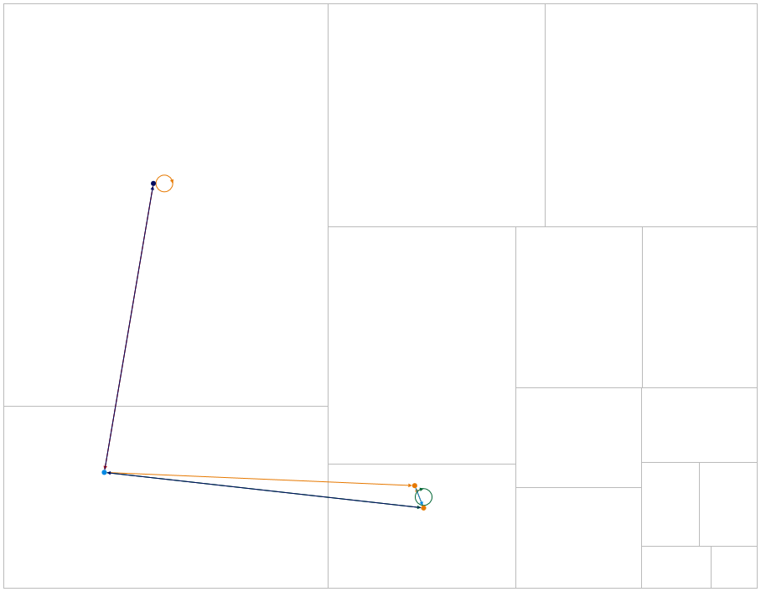

Closeness centrality, on the other hand, is measuring the average distance of a vertex from all of vertices, and eigenvector takes a couple of different factors into account to measure influence. However in this data, neither one allows for much analysis as they are almost entirely grouped at the low end in the sparklines shown in the dynamic filters pane, so adjusting the filter essentially gives you an all or nothing.

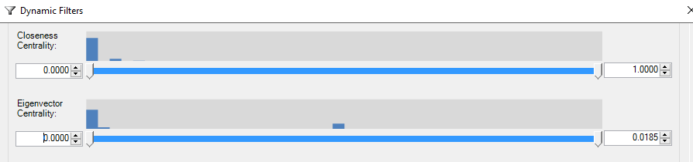

PageRank shows some variation in the histogram, but adjusting the filter up to 1 (left) and then 2(right) has a dramatic effect:



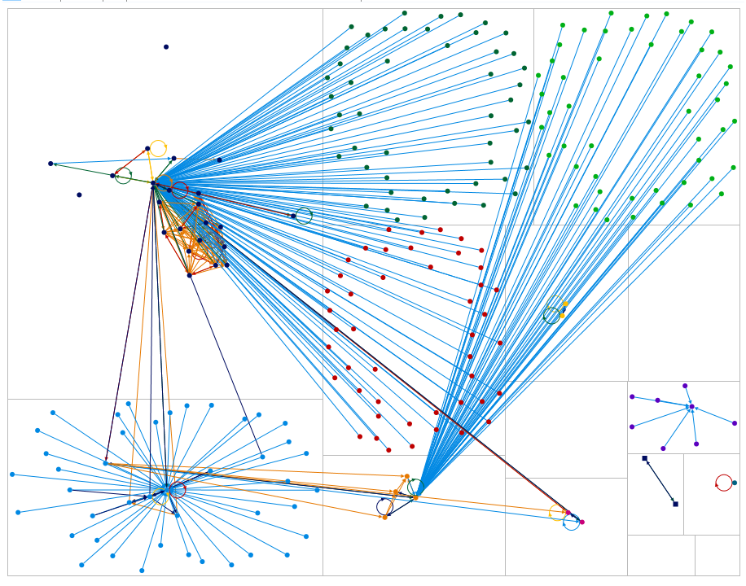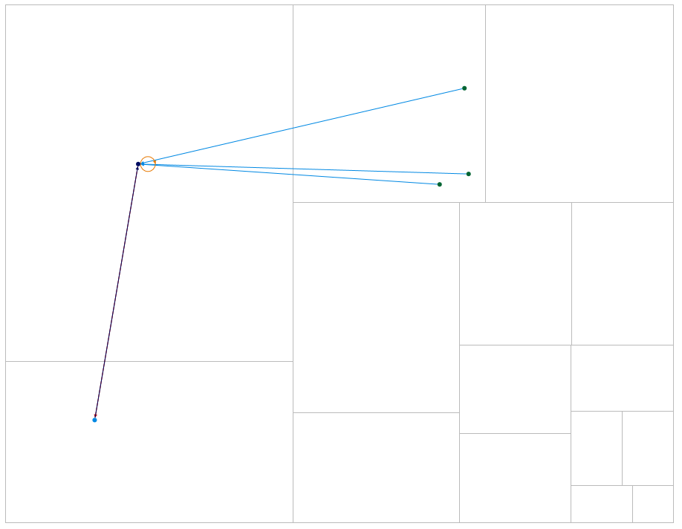

The remaining filters do not tell a lot, because again their spark lines show that most of the values are concentrated at one extreme which means they are essentially binary

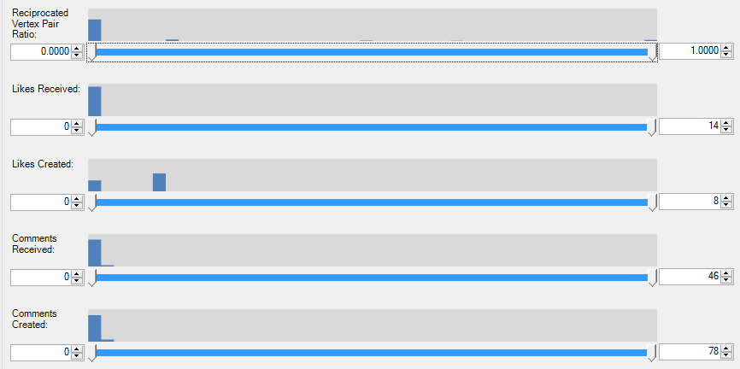

# Results and findings from Facebook

Analysis of the facebook social network data collected reveals a few insights:

* A post can generate quite a bit of reaction, shown clearly in the cases where many lines go between one point and a collection of others which are all in the same group.
* There is not a lot of “depth” to facebook connections. Many of the relationships only go one way, and do not go beyond that.
* Links between posts that do have multiple connections can have several steps to them though, as there is no control over where a post goes.

# Business implications of Facebook network analysis

* Further analysis of what kind of comments or pictures generate the most likes & comments
* Pictures appear to generate a lot of activity. Analysis of a larger dataset should bear this out, assuming so it is worth focusing on making pictures an even larger part of American Airlines online presence.
* Respond to negative posts whenever appropriate as quickly as possible, as they can generate a lot of negative feedback, which can go many steps out.

# Limitations and Recommendations for future research

## Limitations

* The dataset used for analysis has only a small subset of tweets and few days of Facebook pages. This is a very small sample from the original customer base. We should also consider the fact that a major section of the customer base may not be internet savvy.
* The authenticity of the videos posted or customer tweets is not known and it is not verified if they are real customers who actually travelled in American Airlines. There is a possibility of competitors using social media to spread negative opinion about airlines.
* At times the content shared between the vertices did not give any substantive indications about the association of the network, vertices and the search criteria. Interpreting associations was limited because the content was not specific and directed towards an idea that resonated with the goals.
* Social Network analysis works best, however, with clearly definable relationships and where one factor in the relationship correlates well with other factors important in a relationship.  Modern intelligence problems, which often contain, political, economic, competition, geographic, personal, and historical relationship data requires the application of advanced SNA techniques and, even then, may yield little of real use to decision makers.

## 

## Recommendations for future research

* More analytics needs to be done to understand what comments or pictures generate more likes and comments. For example video comments on host of Young Turks thrown out of American Airlines has generated mixed comments from public, we need to understand what the public reactions in detail are. Following the marketing campaigns and promotional activities of American Airlines through paid videos will be very helpful in understanding the customer reviews better.
* Competitor’s social network pages can be analyzed to identify what are the negative reviews provided about American Airlines in their pages. For Eg Southwest airlines customer might have tweeted mentioning about their negative experience in American airlines when compared to positive experience in Southwest airlines.
* Analysis like Response rate, average reply time, pro-active response from American Airlines in social media can be performed through Social network analysis to understand the customer service level of airlines.
* There is also work that could be done to categorize the feedback, link various words, even more visualization, look for robot or paid reviews, look for hot words (for example swear words, or words that are communicated all in CAPS as if shouting).

# Related Research

-Twitter Analysis by Unmetric on American Airlines.

# Conclusion

The yearning of individuals to belong to a group and have a social life on the internet propelled the development of Social Networking websites. Social Networks initially were not very popular with Myspace going down. The rise of Facebook gave way to more social networks like Twitter, Instagram etc. YouTube morphed into another important Social Network.

The individuals in their networks share so much information about their general life experiences. One of those experiences could be the travel experience with American Airlines. Individuals do capture this kind of information in their social network websites by tweeting, posting on YouTube and Facebook. We are tasked to study the perceptions and experiences of individual customers posted on their social networks.

Our Analysis focused on the customer experiences starting from the time the customers book a flight and the end of the flight and leaving the airport. We extracted the data from Twitter, YouTube and Facebook and analyzed the data using NodeXLPro. We executed the functions of Statistical analysis in combination of visual representation. We gathered information about the influential actors by their importance in their networks. We gained valuable insights into how this information is being consumed by the other individuals who are in and outside of their networks with respect to American Airlines customer service.

# References

1. [www.airlinequality.com](http://www.airlinequality.com)
2. BA 741 Course Materials
3. [www.wikipedia.com](http://www.wikipedia.com)
4. <http://www.pewinternet.org/files/2014/02/How-we-analyzed-Twitter-social-media-networks.pdf>
5. http://www.e-ir.info/2014/01/09/the-potential-of-social-network-analysis-in-intelligence/